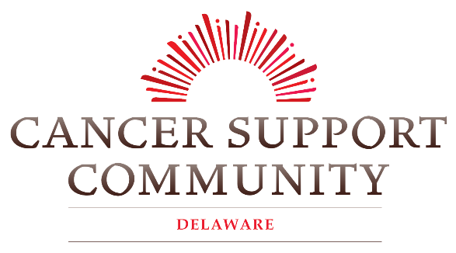

812 S. Bradford Street jsimmons@cscde.org
Dover, DE 19904 (302) 734-0898
Dear Friend,
Cancer Support Community Delaware (CSCDE) is excited to announce the return of our 18th annual Red Balloon Bash: A Central Delaware Luncheon Supporting Strength & Survivors. Typically, this event is a Sunday Brunch held in celebration of the cancer journeys of our participants and the partnerships we have built throughout the community. However due to social distancing mandates we have chosen to be innovative in the way we connect with our community. The Red Balloon Bash will now be a live streamed healthy cooking demonstration. This unique and memorable event is a perfect opportunity to showcase your business and your support for CSCDE at one of our largest fundraisers in 2020.

On March 18th, CSCDE quickly pivoted from in-person services to virtual programming due to the crisis. We are proud to be able to say that we have continued to provide services to our at-risk cancer community; with ZERO days of missed programming. Over 3,300 people statewide have participated in our weekly virtual programs at no cost to the participant, and we are accepting new registrations daily. However, as our number of Delawareans served since the crisis has surged; so, has our loss of funding.
Business sponsorships support CSCDE’s critical work in Central Delaware as non-profit organization, providing support services to cancer patients, caregivers, and their families. Our mission is to ensure that all people impacted by cancer are empowered by knowledge, strengthened by action, and sustained by community. We are a support system every step of the way during each individual’s journey with cancer; from diagnosis to treatment, remission, and beyond. Our support groups, educational workshops, and a wide range of programs including Yoga, Tai Chi, Meditation, Art Therapy, Bereavement, and Nutrition Classes are accessible at no cost to the participant.
Please consider supporting CSCDE as an event sponsor or auction donor for the 2020 Red Balloon Bash! Enclosed, you will find the sponsorship form. You can stay up-to-date with event information, register as a sponsor, and more by visiting us at www.cancersupportdelaware.org.
Thank you for your consideration. Together we can ensure no one in Central Delaware faces cancer alone.

Sincerely,
Jovoni Simmons
Manager of Outreach and Marketing
Cancer Support Community Delaware

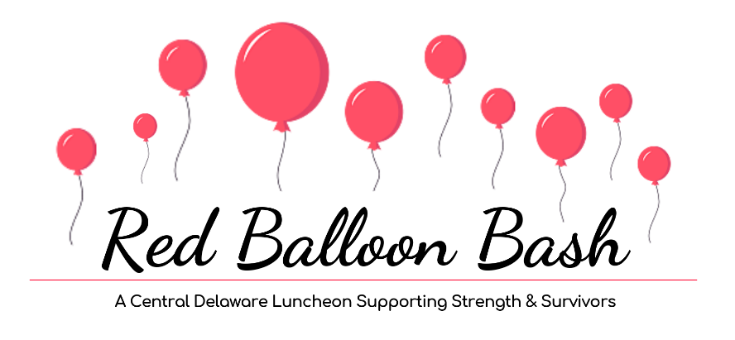
2020 Event Sponsorship
Red Balloon Bash
A Kent County Luncheon Supporting Strength & Survivors
September 13, 2020
Deadline for Business Sponsorship: September 10, 2020

CSCDE is excited to announce the 18th Annual, Red Balloon Bash: A Central Delaware Luncheon Supporting Strength & Survivors, proudly hosted virtually by Hilton Garden Inn in Dover Delaware. Guests are invited to enjoy a cooking demonstration and are encouraged to cook along with Hilton’s notable Chef Gwen as she features a healthy brunch, and specialty Mimosas and Bloody Mary drinks. Red Balloons are sold prior to and at the event in honor/memory of those who have been impacted by cancer and will show cased during the live stream event. We will also be selling raffle tickets for a chance to win great prizes! Our goal is to raise funds that will assist in increasing the variety of critical services and access to them to truly ensure that no one in Kent County faces cancer alone.
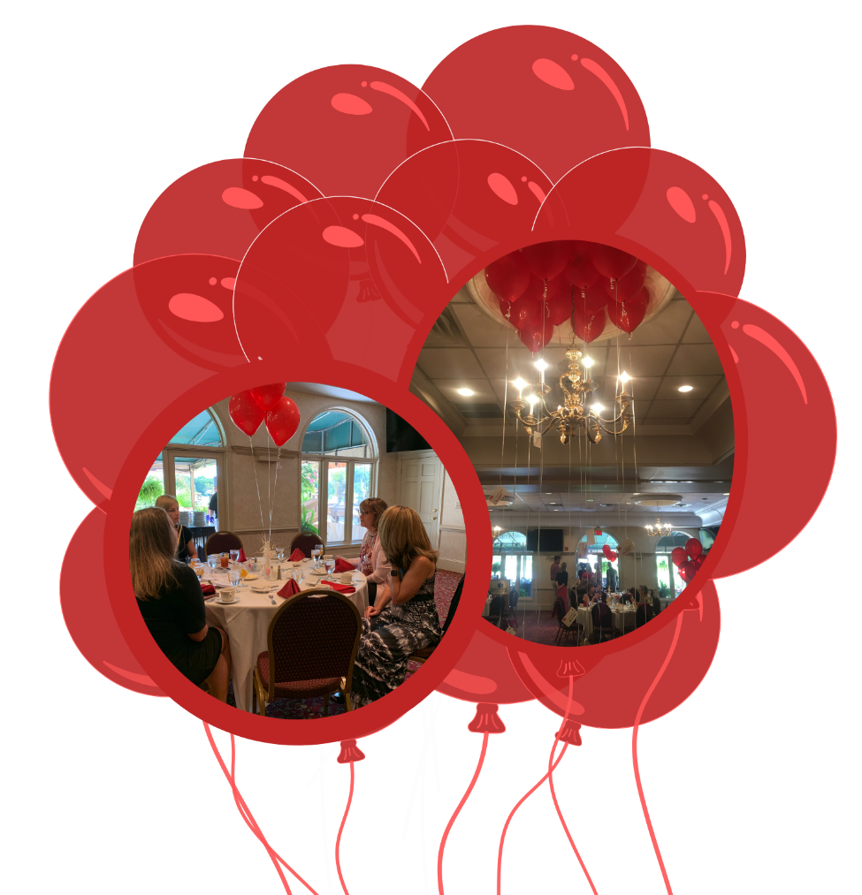
Sponsorship Level | Sponsorship Benefits – Red Balloon Bash
Scarlet Sponsor: $2000 | As a Presenting Sponsor for Red Balloon Bash you will receive 8 complimentary brunch cooking demonstration tickets, the option to give remarks, features on event posters, postcards, and banner, features in all email e-blasts, social media posts, promotion on event website, and featured recognition in press releases.
Rose Sponsor: $1250 | - Name/Company listed on event marketing  - Name/Company featured in all e-blasts  - Name/Company featured in multiple social media posts  - Name/Company listed on event website  - 1 personalized sponsor signs placed throughout event  - 6 Tickets to view the cooking demonstration
Crimson Sponsor: $750 | - Name/Company listed on event marketing  - Name/Company featured in all e-blasts  - Name/Company featured in multiple social media posts  - Name/Company listed on event website  - 1 personalized sponsor signs placed throughout event  - 4 Tickets to view the cooking demonstration
Ruby Sponsor: $500 | - Name/Company listed on event marketing  - Name/Company featured in all e-blasts  - Name/Company featured in multiple social media posts  - Name/Company listed on event website  - 1 personalized sponsor signs placed throughout event  - 2 Tickets to view the cooking demonstration
Auburn Sponsor: $250 | - Name/Company listed on event marketing  - Name/Company featured in all e-blast  - Name/Company featured in 1 social media post  - Name/Company listed on event website

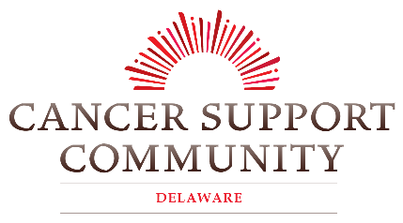
2020 Red Balloon Bash Sponsorship
Deadline: September 10, 2020

SPONSORSHIP LEVELS
- Scarlet: $2,000 (Presenting Sponsor) | - Ruby: $500
- Rose: $1,250 | - Auburn: $250
- Crimson: $750 | - Other ________

Contact Information:
Name/Company (as you would like it to appear in promotional materials):

Address: ____________________________________________________________________________
City: _____________________________ State: ____________________ Zip: __________________
Phone Number: _________________________ E-mail: ____________________________________

Payment Information:
Payment Method: | - Check | - MasterCard | - Visa | - Amex
Credit Card Number: _________________________________________________________________
Name on Card:____________________________________ Exp. Date:_________ CVC: _________
Signature: _____________________________________________ Date: ______________________

Make checks payable to Cancer Support Community of Delaware.
Your donation is tax-deductible to the fullest extent allowed by law. Tax ID # 51-0351863
Please email your logo to: jsimmons@cscde.org (in high resolution jpeg or png format)

For more information contact Jovoni Simmons, Community Liaison at (302) 734-0898 / jsimmons@cscde.org
812 S. Bradford St., Dover, DE 19904

